Communication Systems
Course:
School:
2019.
Design a GPS satellite network with
- promised Quality of Service (QoS)
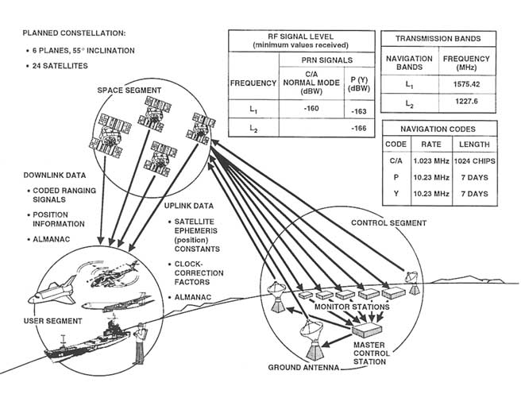
- and a minimum number of satellites
The GPS constellation has 24 GEO satellites which have been arranged in 6 orbital planes which have a 55-degree inclination 35,863Kms above the earth. Each of the satellite completes a satellite orbit each half of the sidereal day which is approximately 23hours and 54 minutes. The orbital configuration allows the user at any point or location in Earth at least 4 satellites every day (Sheriff, & Hu, 2011).
Step 1: Initial problem setting
How many satellites to fix in a certain location
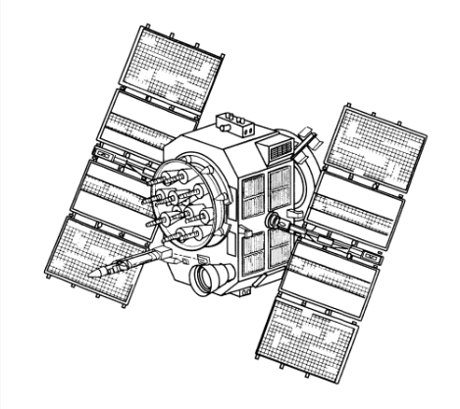

Step 2: Satellite needed
The Geostationary Earth Orbit are needed for this project. The satellites are 35, 863Km above the Earth’s surface and along the equator. The Geostationary orbit around the earth at the same speed just like the Earth rotates. Therefore, the GEO satellites remain in the same position relative to the Earth’s surface. The GEO satellites give a large coverage and can be used almost a fourth of the earth’s surface (Fist, 2016).
Step 3: Improve the QoS
The starting point for improving QoS is to avoid congestion. For example, the freeway congestion where many vehicles get into freeway congestion without the regard of any existing congestion. The more users who get into the network, the contestation gets worse.
In order to help improve on the performance and reliability of the satellites, it is important to work on the batteries, solar arrays, weather challenges, and nuclear-detection. Each navigation payload on Block IIX ought to have two rubidium clock. In order to improve on performance, the following techniques can be used;
- End-system flow control
The techniques present the sender from overrunning the receiver buffers. The technique helps in flow control mechanisms.
- Network congestion control
In this technique, end-to-end flow controls reduce congestion in the network even in severe weather situations.
- Network-based congestion avoidance
The router detects the congestion and slows the users before the queue becomes too long
- Resource allocation
It is important to install circuits such as the virtual circuits in order to guarantee the bandwidth (Sheriff, & Hu, 2011)

References
Fist, S. (2016). The Informatics Handbook: A guide to multimedia communications and broadcasting.
Sheriff, R. E., & Hu, Y. F. (2011). Mobile satellite communication networks.
http://www.agi.com/news/blog

